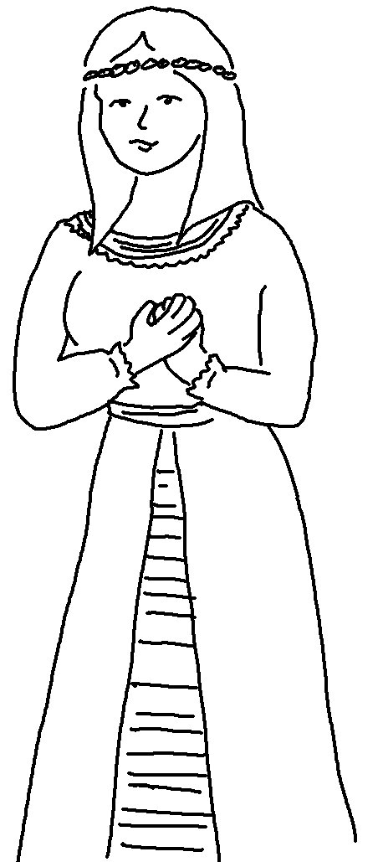

Who knows if perhaps you were made queen for just such a time
as this?

Esther 4:14

